Bahria University,

Karachi Campus



LAB EXPERIMENT NO.

4

LIST OF TASKS

|  |  |
| --- | --- |
| TASK NO | OBJECTIVE |
| **1** | Write a sketch to interface Arduino with a 3 x 4 Matrix Keypad. The display of the pressed key should be displayed on the LCD. |
| 2 | Write a sketch that works as security keypad lock. Set any password. If the input password matches with the set password, Green LED should glow, otherwise Red LED will glow. |

Submitted On:

27/10/2022

(Date: DD/MM/YY)

**Task No. 1:** Write a sketch to interface Arduino with a 3 x 4 Matrix Keypad. The display of the pressed key should be displayed on the LCD.

**Output:**

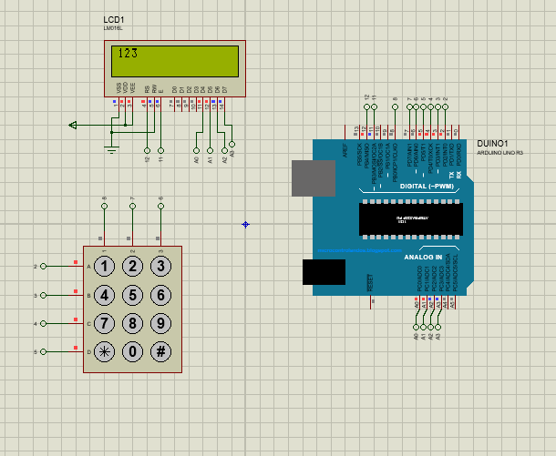

**Task No. 2:** Write a sketch that works as security keypad lock. Set any password. If the input password matches with the set password, Green LED should glow, otherwise Red LED will glow.

**Output:**

